Project Design Phase-II
Technology Stack (Architecture & Stack)

Date | 30 September 2026
Team ID | MKU201Team56ab4dc836f290be8a6b49be8
Project Name | Import Data Using Transform Maps (ServiceNow Micro Project)
Maximum Marks | 4 Marks

Technical Architecture:
The Deliverable shall include the architectural diagram as below and the information as per the table1 & table 2
Technical Architecture – Employee data import in ServiceNow
Source spreadsheet → ServiceNow Load Data → Import Set → Transform Map → Target table → Reports → Dashboardhttps://developer.ibm.com/patterns/ai-powered-backend-system-for-order-processing-during-pandemics/
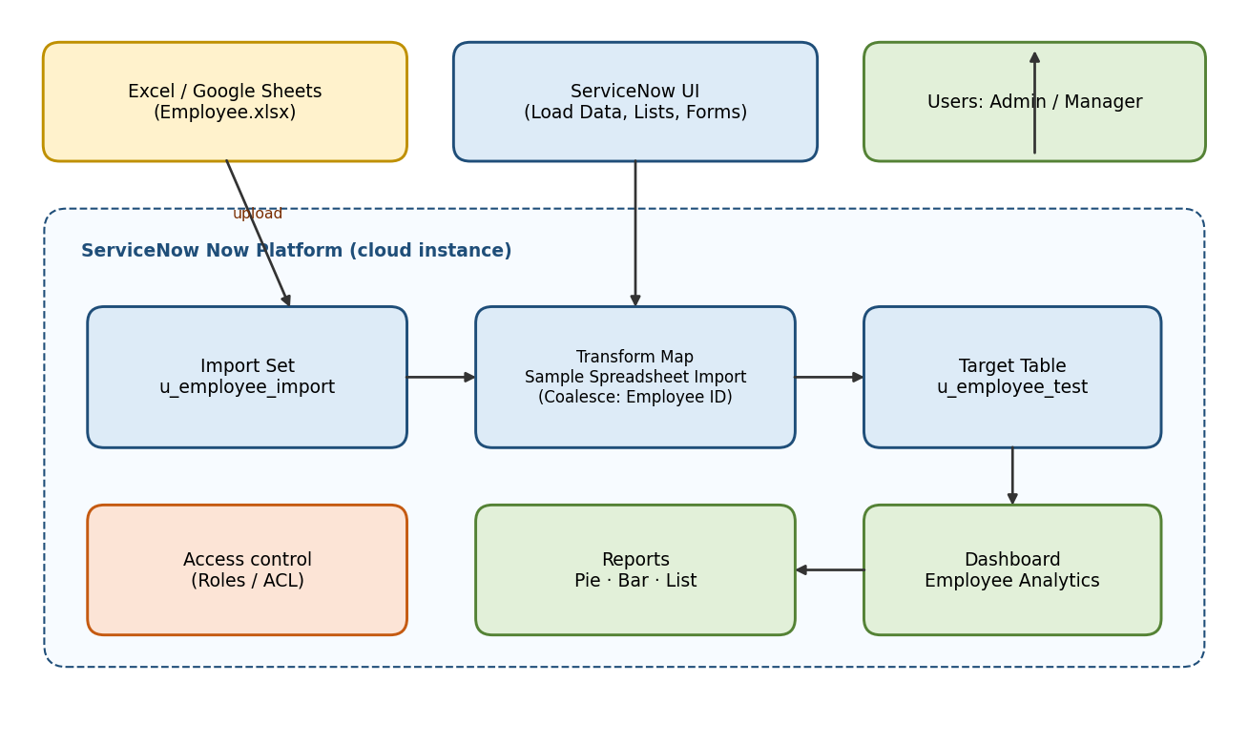

Table-1 : Components & Technologies:
S.No | Component | Description | Technology
- 1 | User Interface | ServiceNow web UI – Application Navigator, Load Data, forms, lists, dashboards | ServiceNow Now Platform UI
- 2 | Application Logic-1 | Load Data / Import Set: uploads the .xlsx file into a staging table | ServiceNow Import Sets
- 3 | Application Logic-2 | Transform Map with field maps and Coalesce on Employee ID | ServiceNow Transform Maps
- 4 | Application Logic-3 | Reports (pie, bar, list) and dashboard on the target table | ServiceNow Reports & Dashboards
- 5 | Database | Staging table u_employee_import and target table u_employee_test (five String fields) | ServiceNow tables (relational)
- 6 | Cloud Database | Instance-hosted database that stores all imported records | ServiceNow cloud instance
- 7 | File Storage | Source Microsoft Excel (.xlsx) file prepared in Google Sheets / Excel and attached to the import set | Excel / Google Sheets, ServiceNow attachments
- 8 | External API-1 | Not used – data is loaded from a file | N/A
- 9 | External API-2 | Not used | N/A
- 10 | Machine Learning Model | Not applicable | N/A
- 11 | Infrastructure (Server / Cloud) | Application deployed on a ServiceNow instance in the cloud (no local server needed) | ServiceNow Cloud instance

Table-2: Application Characteristics:
S.No | Characteristics | Description | Technology
- 1 | Open-Source Frameworks | Low-code platform; only Google Sheets / Excel used for source data | ServiceNow, Excel / Google Sheets
- 2 | Security Implementations | Role-based access, ACLs on tables and dashboards; only authorized admins change access controls; HTTPS access to the instance | ServiceNow roles & ACLs
- 3 | Scalable Architecture | Staging table + transform map separates loading from mapping; reusable for bigger files | ServiceNow Import Set architecture
- 4 | Availability | Cloud-hosted instance managed by ServiceNow | ServiceNow cloud
- 5 | Performance | Bulk import through import sets; aggregate reports (count group-by) on indexed table data | ServiceNow Reporting

References:
https://c4model.com/
https://developer.ibm.com/patterns/online-order-processing-system-during-pandemic/
https://www.ibm.com/cloud/architecture
https://aws.amazon.com/architecture
https://medium.com/the-internal-startup/how-to-draw-useful-technical-architecture-diagrams-2d20c9fda90d

